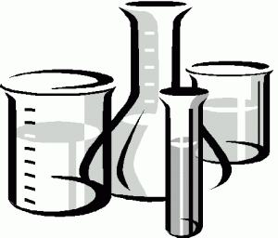
Capstone Assignments & Reflections
As part of your senior portfolio, you must select FIVE assignments that you consider most representative of your progress and achievement throughout high school, and write a 1-2 paragraph reflection for each selected capstone assignment.
Here are the options for work* that you can select for your capstone assignments:
- samples of what you would consider your best or most important work
- samples of your favorite work or one you considered most interesting
- samples of work that had undergone significant revision (include parts of the revision process)
- samples of work that influenced or sparked your future academic/career interests
- samples of work that you found particularly challenging and are proud of what you achieved
- samples of work that demonstrate how you have achieved the AV Student Learning Outcomes
*Work can be essays, projects, creative pieces, exams, labs, etc. If you are not sure if something qualifies as an assignment or work, ask your advisor.

For each capstone assignment that you choose upload to your Google Portfolio AND write a 1-2 paragraph reflection answering one or more of the following questions:
- Why did you pick this assignment rather than others in your portfolio?
- How does this assignment qualify as your best work?
- How does this assignment show evidence of your academic growth?
- What kinds of risks did you take a risk when completing this assignment?
- What kinds of challenges did you overcome in completing this assignment?
- How does the assignment illustrate your understanding and achievement of the school wide learning outcomes?

Remember to be clear and give specific examples from the assignment. Do not be vague!

All reflections must be neatly typed!

Assignment/ Essay / Picture of Model/ Experimental Lab Report
Written Reflection

